**Computer networks laboratory week 8**

**Name: Pranav R. Hegde SRN: PES1UG19CS343 Section: F1**

**Mandatory: Topology 1**

Task 1: Building a topology in Claynet and deploying it.

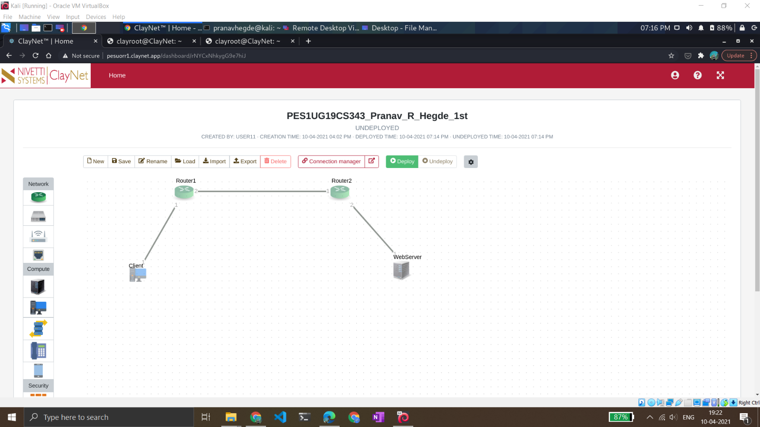

Task 2: Configuring the Client PC and Webserver PC

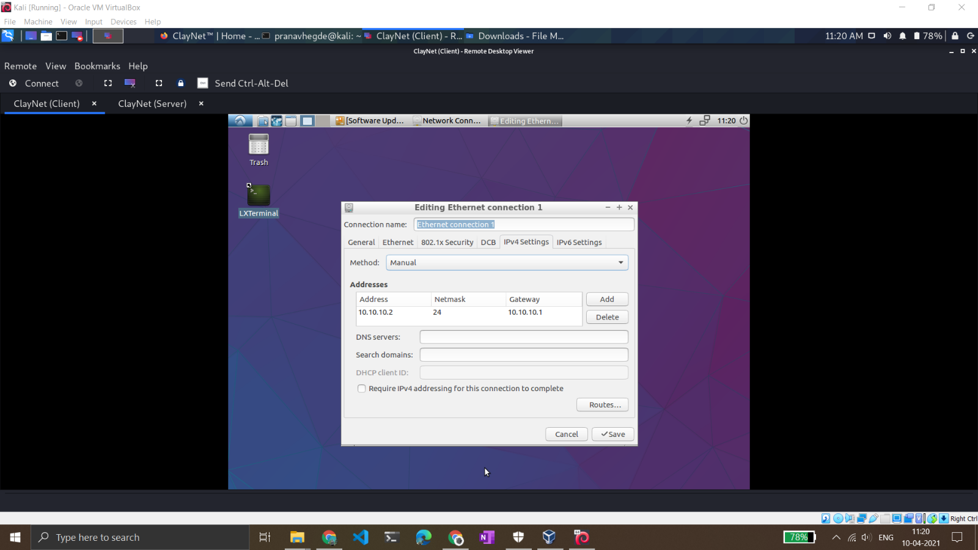

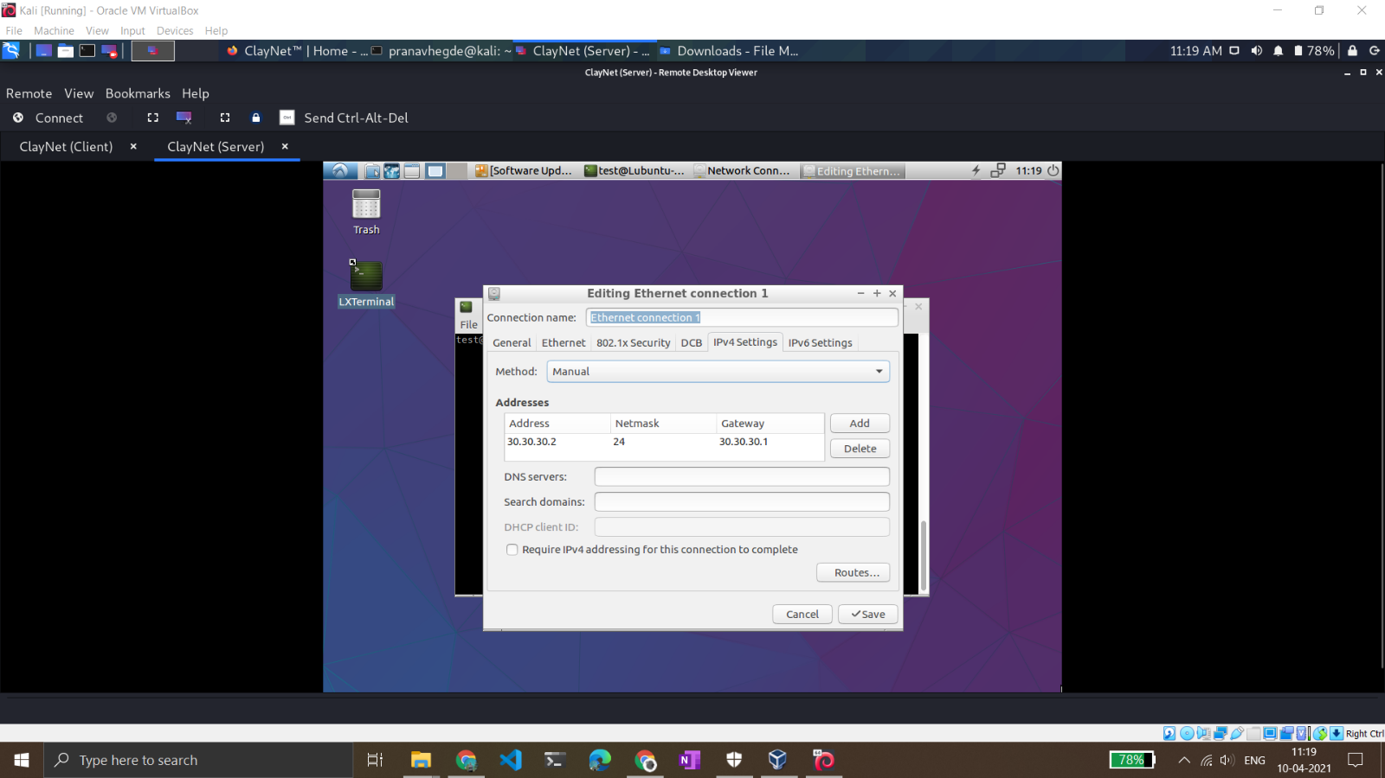

Task 3: Configuring the router1 and router2 via console access.

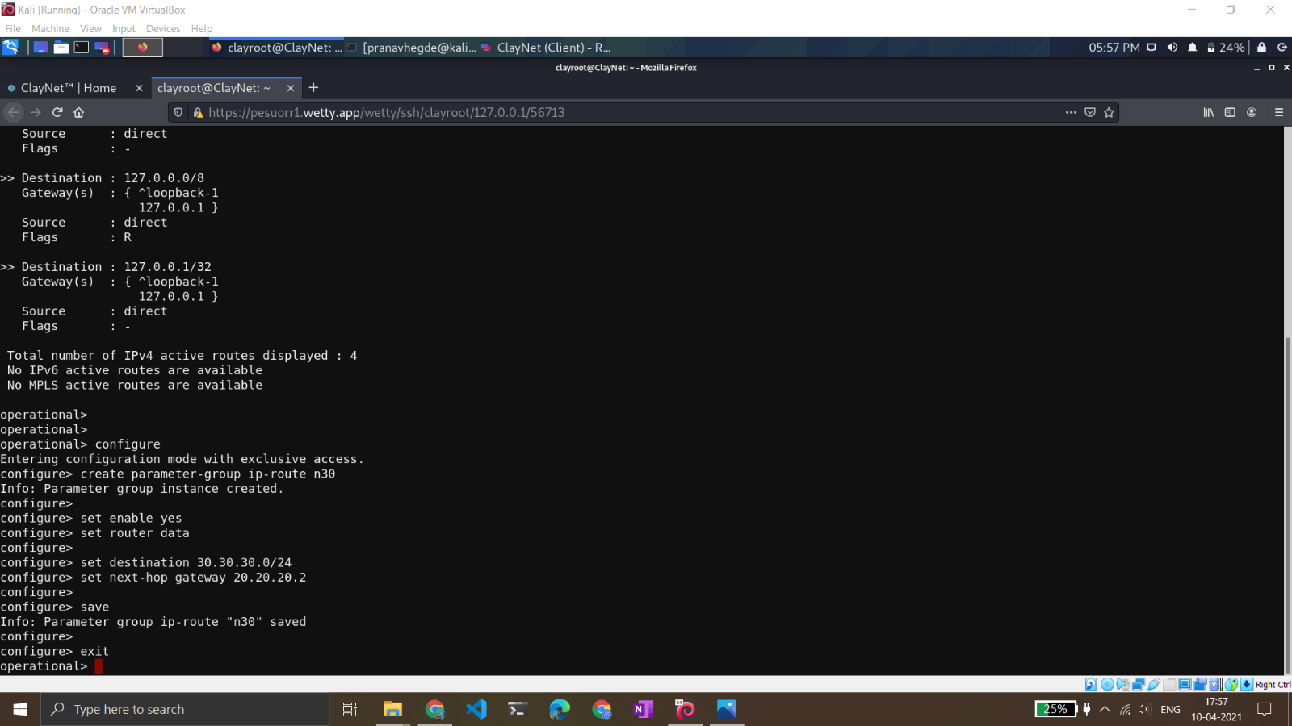

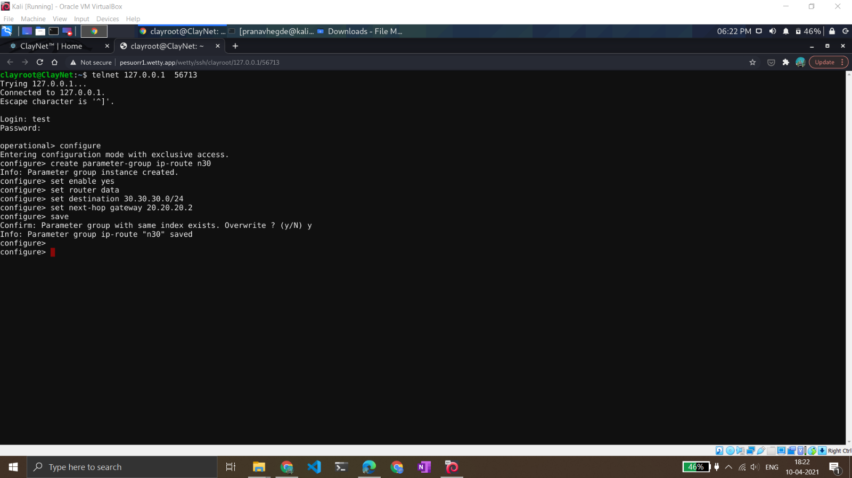

Task3: Observe the ping in Wireshark and terminal

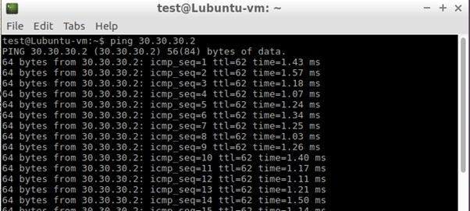

* We can observe here that the ttl is 62 because of the two routers used in between.

